MNI RBI Preview – December 2025.

Meeting Date: Friday, December 5, 2025
Link To Prior Statement: https://www.rbi.org.in/Scripts/BS_PressReleaseDisplay.aspx?prid=61332

Contents

- Pages 1-3: MNI POV: RBI to Cut, Signal End to Easing
- Pages 4-5: RBI October 1, 2025: Monetary Policy Statement
- Pages 6-7: Sell-Side Analyst Views

MNI POV (Point of View): RBI to Cut, Signal End to Easing

At the last meeting for 2025, we expect the Monetary Policy Committee to cut rates by 25bps whilst signalling to the market that the rate cutting cycle has ended. The Bloomberg Survey sees only 12 of 40 economists forecasting no change.

Inflation remains the key focus for the RBI following October’s record low print of 0.25% YoY with wholesale prices also turning negative. Expectations are that inflation has bottomed out with the base effect beginning to reverse from November onwards. October’s release sees CPI missing the RBI’s revised (lower) forecasts by circa 100bps and a further undershoot from here would be difficult for the RBI to ignore, creating strong support for policy intervention to avoid deflation.

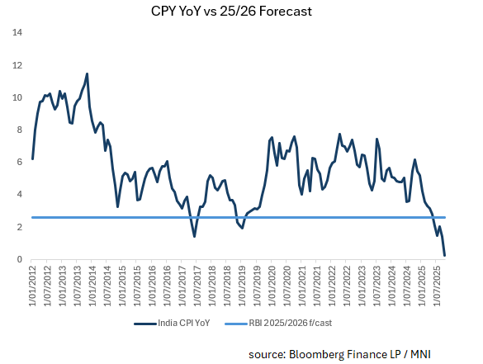
India’s third quarter growth surprised to the upside at 8.2% YoY, eclipsing the second quarter result of 7.8%. Manufacturing’s strength has continued despite US tariff threats with financial services, construction and real estate’s growth contributing positively. Exports served as an important tailwind, with services exports acquiring a structurally stronger footing due to the expansion in global capability centres. Initially established for cost-saving back-office operations, Indian GCCs have evolved into critical drivers of digital transformation and value creation, handling a wide array of complex, high-value functions. The government’s CAPEX spend continues to support this and is at near-term highs which in turn is giving confidence to private CAPEX intentions. Real Private Final Consumption Expenditure grew by 7.9% in Q3, up from 6.4% in the same period the previous year. This was supported by easing inflation and strong rural demand following a good monsoon.

The concerns that the MPC will likely point to will be the moderation of PMIs (albeit from all time highs) and October’s decline in exports as a worrying sign as some market commentators suggest that this is the impact of US tariffs finally showing up in the data.

Echoing the decline in exports was the worst month in October for Industrial Production for more than a year. Rising just 0.4% YoY it undershot expectations of 2.5% YoY though September’s release was revised up to 4.6% (from 4.0%). A theme throughout the region has been the ramping up of shipments prior to the Trump-Xi meeting in October, followed by a tailing off. It is a possibility that this is also the trend in India’s October’s data, yet without a trade deal with the US, risks remain to the outlook going forward.

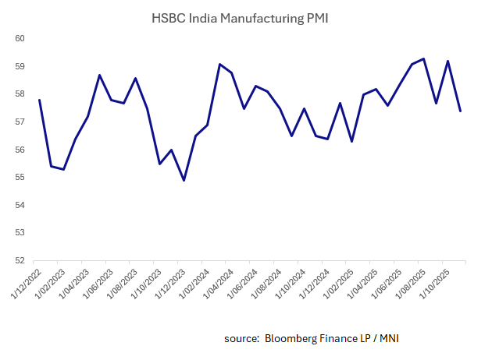

The risks continue for the currency with INR losses of nearly 5% over the last six months. Governor Malhotra in a TV interview last week, gave a particularly strong steer on rates, possibly for currency markets to adjust in advance. A cut could put pressure on INR, but it is likely to be mild. The RBI has done a good job of managing INR volatility through the use of their forward book and they have near all-time records of FX reserves.

Market pricing is interesting with the 2-yr IGB maintaining a premium over the base rate. At +30bps it could be interpreted that a rate cut remains unlikely. In the period from when the rate cutting cycle began, the yield premium has averaged +22bps, reaching a high of +53bps in early September. The swaps market does not have a cut priced in either with little expectation over the next 12 months.

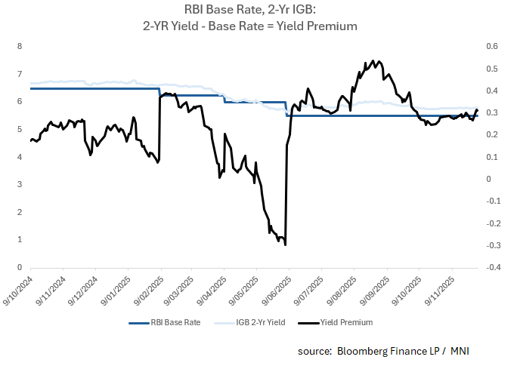

In a recent TV interview, the Reserve Bank of India (RBI) Governor Sanjay Malhotra indicated that there is scope for a repo rate cut at the next monetary policy meeting in early December 2025. This was based on favourable macroeconomic indicators, including benign inflation data. The key points from the interview were Malhotra stating that recent data, including low retail inflation, supports a potential interest rate reduction; that the Monetary Policy Committee (MPC) had previously indicated room for policy easing during its October meeting and that there is "certainly room" to lower rates. He did however emphasize that the final decision rests with the MPC at its upcoming meeting and that the RBI's priority is managing excessive volatility in the rupee rather than defending any particular exchange rate level.

Lastly, an excerpt from the press release from the prior MPC meeting, seems to provide further support to the Governor’s comments recently. “The prevailing global uncertainties and tariff related developments are likely to decelerate growth in H2:2025-26 and beyond. The current macroeconomic conditions and the outlook has opened up policy space for further supporting growth.”

Therefore, despite market pricing suggesting a cut is not a foregone conclusion, we forecast the RBI to cut rates at its last meeting of the year, whilst signalling an end to the easing cycle.

Monetary Policy Statement, 2025-26 Resolution of the Monetary Policy Committee September 29 to October 1, 2025
Monetary Policy Decisions

The Monetary Policy Committee (MPC) held its 57th meeting from September 29 to October 1, 2025, under the chairmanship of Shri Sanjay Malhotra, Governor, Reserve Bank of India. The MPC members Dr. Nagesh Kumar, Shri Saugata Bhattacharya, Prof. Ram Singh, Dr. Poonam Gupta and Shri Indranil Bhattacharyya attended the meeting.

2. After a detailed assessment of the evolving macroeconomic and financial developments and the outlook, the MPC voted unanimously to keep the policy repo rate under the liquidity adjustment facility (LAF) unchanged at 5.50 per cent; consequently, the standing deposit facility (SDF) rate remains at 5.25 per cent while the marginal standing facility (MSF) rate and the Bank Rate remains at 5.75 per cent. The MPC also decided to continue with the neutral stance.

Growth and Inflation Outlook

3. The global economy has been more resilient than anticipated in 2025, with robust growth in the US and China. The outlook, however, remains clouded amidst elevated policy uncertainty. Inflation has remained above their respective targets in some advanced economies, posing fresh challenges for central banks as they navigate the shifting growth-inflation dynamics. Financial markets have been volatile. The US dollar strengthened after the upward revision of US growth numbers for the second quarter, and treasury yields hardened recently tracking changes in policy rate expectations. Equities have remained buoyant across several advanced and emerging market economies.

4. In India, real gross domestic product (GDP), driven by strong private consumption and fixed investment, recorded a robust growth of 7.8 per cent in Q1:2025-26. On the supply side, growth in gross value added (GVA) at 7.6 per cent was led by a revival in manufacturing and steady expansion in services. Available high frequency indicators suggest that economic activity continues to remain resilient. Rural demand remains strong, riding on a good monsoon and robust agriculture activity, while urban demand is showing a gradual revival. Revenue expenditure of the Union and State Governments registered robust growth during the fiscal year so far (April-July). Investment activity, as suggested by healthy growth in construction indicators i.e., cement production and steel consumption in July-August, is holding up well even though production and import of capital goods witnessed some moderation. Recovery in manufacturing sector continues while services activity is sustaining its momentum.

5. Looking ahead, an above normal monsoon, good progress of kharif sowing and adequate reservoir levels have further brightened prospects of agriculture and rural demand. Buoyancy in services sector coupled with steady employment conditions are supportive of demand, which is expected to get a further boost from the rationalisation of goods and services tax (GST) rates. Rising capacity utilisation, conducive financial conditions, and improving domestic demand should continue to facilitate fixed investment. However, ongoing tariff and trade policy uncertainties will impact external demand for goods and services. Prolonged geopolitical tensions and volatility in international financial markets caused by risk-off sentiments of investors also pose downside risks to the growth outlook. The implementation of several growth-inducing structural reforms, including streamlining of GST are expected to offset some of the adverse effects of the external headwinds. Taking all these factors into account, real GDP growth for 2025-26 is now projected at 6.8 per cent, with Q2 at 7.0 per cent, Q3 at 6.4 per cent, and Q4 at 6.2 per cent. Real GDP growth for Q1:2026-27 is projected at 6.4 per cent (Chart 1). The risks are evenly balanced.

6. Headline CPI inflation declined to its eight-year low of 1.6 per cent (y-o-y) in July 2025 before rising to 2.1 per cent in August – its first increase after nine months. Benign inflation conditions during 2025-26 so far have been primarily driven by a sharp decline in food inflation from its peak of October 2024. Inflation within the fuel group moved in a narrow range of 2.4-2.7 per cent during June-August. Core inflation remained largely contained at 4.2 per cent in August. Excluding precious metals, core inflation was at 3.0 per cent in August.

7. In terms of the inflation outlook for H2: 2025-26, healthy progress of the south-west monsoon, higher kharif sowing, adequate reservoir levels and comfortable buffer stock of foodgrains should keep food prices benign. The recently implemented GST rate rationalisation would lead to a reduction in prices of several items in the CPI basket. Overall, the inflation outcome is likely to be softer than what was projected in the August MPC resolution, primarily on account of the GST rate cuts and benign food prices. Despite the anticipation of moderate momentum during H2, large unfavourable base effects are likely to exert upward pressure on headline CPI inflation, especially in Q4. Considering all these factors, CPI inflation for 2025-26 is now projected at 2.6 per cent with Q2 at 1.8 per cent; Q3 at 1.8 per cent; and Q4 at 4.0 per cent. CPI inflation for Q1:2026-27 is projected at 4.5 per cent (Chart 2). The risks are evenly balanced.

8. The MPC observed that the overall inflation outlook has turned even more benign in the last few months, due to the reasons discussed above. The average headline inflation for 2025-26 is now revised lower from 3.7 per cent and 3.1 per cent projected in June and August policy, respectively, to 2.6 per cent. Headline inflation for Q4:2025-26 and Q1:2026-27 too have been revised downwards and are broadly aligned with the target, despite unfavourable base effects. Core inflation for this year and Q1:2026-27 is also expected to remain contained.

9. Growth outlook remains resilient supported by domestic drivers, despite weak external demand. It is likely to get further support from a favourable monsoon, lower inflation, monetary easing and the salubrious impact of recent GST reforms. However, growth continues to be below our aspirations. Even though the growth projection for the financial year 2025-26 is being revised upwards, the forward-looking projections for Q3 and beyond are expected to be slightly lower than projected earlier, primarily due to tariff-related developments, despite being partially offset by the impetus provided by the rationalisation of GST rates.

10. To summarize, there has been a significant moderation in inflation. Moreover, the prevailing global uncertainties and tariff related developments are likely to decelerate growth in H2:2025-26 and beyond. The current macroeconomic conditions and the outlook has opened up policy space for further supporting growth. However, the MPC noted that the impact of the front-loaded monetary policy actions and the recent fiscal measures is still playing out. The trade related uncertainties are also unfolding. The MPC, therefore, considered it prudent to wait for the impact of policy actions to play out and greater clarity to emerge before charting the next course of action. Accordingly, the MPC unanimously voted to keep the policy repo rate unchanged at 5.5 per cent. The MPC also decided to retain the stance at neutral. However, two members - Dr. Nagesh Kumar and Prof. Ram Singh, were of the view that the stance be changed from neutral to accommodative.

11. The minutes of the MPC’s meeting will be published on October 15, 2025.

12. The next meeting of the MPC is scheduled during December 3 to 5, 2025.

Sell-Side Analyst Views

ANZ: (cut): “The RBI’s Monetary Policy Committee (MPC) will meet on 3–5 December 2025, and we
expect a final 25bp cut in the repo rate, bringing it down to 5.25%. This expectation is driven by record-low inflation in October that fell to 0.3% y/y – the lowest in the new CPI series – undershooting RBI’s revised forecasts. Food inflation has been weaker than anticipated, and core inflation excluding gold remains soft, signalling no demand-side pressure in the economy. GST rate cuts effective from late September are being passed through, reinforcing the view that core inflation will stay contained. Growth remains resilient but its momentum likely eased in October in some pockets, partly due to tariff effects, according to high frequency data such as foreign trade. Without a trade deal, downside risks persist, keeping growth below potential. This creates a strong case for
RBI to use the policy space afforded by disinflation. While another cut may not significantly accelerate credit growth, it can ease household debt servicing costs after years of personal credit expansion, freeing income for consumption. Real rates remain elevated, and bond yields have risen, reversing earlier transmission and forcing the MPC to act. A surprise cut could exert mild pressure on the INR, but the RBI is expected to manage volatility through other tools (FX reserves and forward book) while prioritizing domestic growth and inflation objectives. Overall, with inflation at historic lows and growth risks still present, a final 25bp cut appears justified to reinforce accommodative conditions and support demand.

BoNY (cut): “With strong signs that economic growth is slowing, we expect the RBI to lower interest rates by 25bp to 5.25% to help stimulate the economy. The headline inflation rate is low at 0.25% y/y, which supports this move, though rising core inflation is a concern. While a weaker rupee could argue against easing, history suggests otherwise – the RBI reduced rates in February 2025 despite the USDINR reaching a record high of 87.43.”

Goldman Sachs (cut): “We continue to expect the RBI Monetary Policy Committee (MPC) to deliver a 25bp repo rate cut on December 5, lowering the repo rate to 5.25%, while maintaining the “neutral” stance and signalling a data-dependent approach from here. Real GDP growth is likely to sequentially moderate in Q3 (vs. Q2), though the year-over-year (yoy) growth may come in strong at 7.4%, on a low base. High frequency data in October point to a sequential recovery driven by stronger consumption demand amid GST rate cuts and the festive season tailwinds. Headline inflation declined to an all-time low of 0.3% yoy in October, but adverse base effects are likely to push it closer to 4.5% yoy by mid-CY26. A range of Taylor rule estimates point to one 25bp rate cut over the next year based on our 12-month ahead headline inflation forecast, consistent with our view.”

JPM (cut): “We anticipate that the RBI will deliver a final 25 basis point rate cut at its December policy meeting. Despite growth exceeding expectations, inflation is forecast to become increasingly subdued. Headline CPI is expected to average 2.1% yoy for this fiscal year, with the current quarter at just 0.7% and the first quarter of 2026 at 3.2%. These figures are 80 to 110 basis points lower than the RBI’s projections from the October monetary policy statement. With inflation already at low levels, a further undershoot of 80 to 100 basis points compared to the RBI’s October estimates will be difficult for the central bank to overlook. As a result, we expect the RBI to act in line with its inflation targeting framework and reduce rates by 25bps.

SOCGEN (cut):” We expect the RBI to potentially announce the final rate cut of the ongoing easing cycle—by 25 bps to 5.25%—supported by headline inflation dropping to an all-time low of 0.25% yoy, largely driven by a strong base effect. While there is a clear case for another rate cut, any further delay could complicate matters for the central bank as inflation is expected to inch up from here, with the base effect reversing meaningfully from November. For a central bank closely monitoring real GDP growth, macro indicators appear robust at first glance. However, while low inflation and strong real GDP growth may seem reassuring, we remain less sanguine about the growth outlook. Real GDP growth is being buoyed by the use of an inappropriate (read: non-representative) deflator, whereas weak nominal GDP growth should raise concerns—especially given that many high-frequency indicators look far less encouraging. Adding to the challenge is the INR’s drop to an all-time low. In fact, a weakening currency and stubbornly high bond yields (the 10-year yield has barely fallen by 40 bps since the rate-cut cycle began) signal deeper macroeconomic challenges: shrinking fiscal space, low private investment, weak productivity, and domestic demand normalising rapidly after the GST rate-cut-induced spike in select categories. Currently, the RBI faces the challenge of limited monetary policy transmission. Beyond external factors, the abrupt shift in policy stance to neutral—following a cumulative 100 bps cut over three consecutive meetings, coupled with assurances of ample banking system liquidity—has also contributed to weaker transmission. With the real policy rate now at its highest-ever level (well above the acceptable range of 1.5–2.0%), this may be the RBI’s last opportunity to announce a rate cut to support growth and accelerate monetary policy transmission.

UOB: (hold):” According to the Bloomberg Survey (as of 28 Nov), of the six analysts polled, five expect the RBI to lower the policy Repo rate by 25-bps to 5.50% but one analyst forecasts the RBI to stay on hold in Dec. Our economist, Jester Koh, is with the minority as he maintains the RBI policy repo rate forecast at 5.50% at the upcoming meeting and into 2026. While he sees scope for a further 25bps cut to the policy repo rate to support growth, the policy forecast will be reassessed based on incoming data including the 3Q GDP data on 28 Nov.

Unauthorized disclosure, publication, redistribution or further dissemination of this information July result in criminal prosecution or other severe penalties. Any such authorization requires the prior written consent of Market News International. Redistribution of this information, even at the instruction of your employer, July result in personal liability or criminal action unless such redistribution is expressly authorized in writing by Market News International. Violators will be prosecuted. This information has been obtained or derived from sources believed to be reliable, but we make no representation or warranty as to its accuracy or completeness. This is not an offer or solicitation of an offer to buy/sell. Copyright © 2024 Market News International, Inc. All rights reserved.

